RIHAM AHAMED ABDUL RAHEEM

HND COMPUTING IDM

CONTINUING PROFESSIONAL DEVELOPMENT

Contents

**Examining the need for contributing for Continuing Professional Development (CPD) and its role within the workplace and for higher level learning** 1

**Importance of Continuing Professional Development** 1

Importance of CPD 2

**Evaluation of Continuing Professional Development** 3

Feedback methods 3

**List of figure**

Figure 1: CPD wheel 1

Figure 2: Feedback 3

# **Examining the need for contributing for Continuing Professional Development (CPD) and its role within the workplace and for higher level learning**

## **Importance of Continuing Professional Development**

**Continuing Professional Development:**

Continuing Professional Development (CPD) is the means by which members of respective professions develop, maintain, improve and broaden their knowledge and skills and develop the personal qualities required to uplift their professional development.

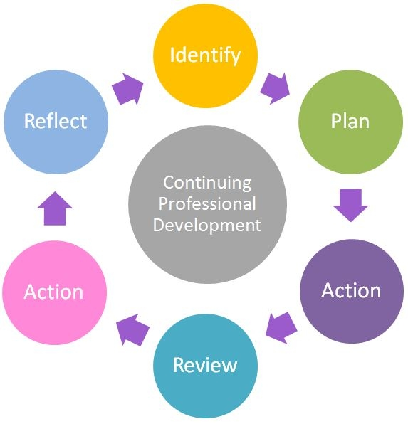CPD is a platform which provides continuous development of professional knowledge, in the form of skills, values, ethics and attitudes, and the competence necessary to improve the knowledge required in career development. (2018, CA Sri Lanka)

Figure 1: CPD wheel

### Importance of CPD

Many professions have set boundaries for achieve it, where it is necessary for individuals to prove they are capable of adhering to current essential standards.

But beyond that, CPD helps to retain a consistent set of high quality, relevant skills and knowledge throughout their professional life. The best part is that CPD puts learners in a favourable position to demonstrate new knowledge, work to impressive standards, and progress in their career.

As a young management trainee CPD helps to the learner to develop and review his interpersonal skills in the industry. The CPD helps to the learner for keeping skills relevant is integral in today’s fast-moving world, where rapid progression can quickly lead to previous learning becoming obsolete. He can able to understand required skills to survive in the industry from the CPD training including achieving higher salaries and better job security. CPD gives experience and influence to the learner to manage the future challenges. Personally, for the developer he could able to improve his leadership skill through the training event. CPD gave force to the learner for learning knowledge and new skills. The learner learns quicker as he become acquainted with the process and will become a better independent learner through continuing professional development.

CPD helps to showcase and demonstrate our talents and professional sanding to our clients and superiors. Not only has that but also leaded to acquiring new skills for promotion. Through the training event we learned new skill, knowledge, and experience. It is wonderful opportunity to showcase our talents and innovative ideas. CPD leads to determine the strength and the weakness of the learner, which really helps to improve professional competence. The learner can improve his self-confidence, self-awareness, abilities and non-abilities through continuing this kind of training event. Furthermore, the learner can be updated with the industry when he continuing professional development.

The learner hopes CPD will helps him to get a good profession in future. Not only that but also it can be help to the learner to get promotions in his profession. CPD has often been identified as an essential part of lifelong learning. Continuing professional development really helps us to cope with the competitive world.

## **Evaluation of Continuing Professional Development**

### Feedback methods

**Feedback:**

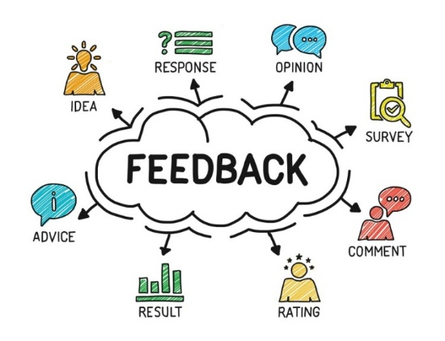Feedback is an event that occurs when the output of a system is used as input back into the system as part of a chain of cause and effect. This alters variables in the system, therefore resulting in different output and consequently different feedback as well, which can either be good or bad. (2018, Techopedia Inc)

Figure : Feedback

**Importance of Feedback**

The main purpose of feedback is gathering information from others to improve ourselves.

In fact, what is viewed as negative feedback is actually a constructive criticism and is the best find of feedback that can help to formulate better decisions to improve and increase performance. Quality feedback simply lists negative and positive observations about the work. Feedback takes an important part in CPD. Without the feedback a trainee does not know his progress.

Here are some feedbacks taking methods:

* + - 1. **Interview –** There are many types interview existed to many purpose. Evaluation interview takes an important part in feedback method. The interviews, which take place to review the progress of the interviewee, are called the evaluation interviews. Naturally, it is occurring between superiors and subordinates. The main objective of this interview is to find out the strengths and weaknesses of the employees.
      2. **Questionnaire -** A questionnaire is a research instrument consisting of a series of questions for the purpose of gathering information from respondents. Questionnaire helps to gather feedback with asking list of questions to the respondents.
      3. **Observations –** The process of closely observing and noticing things, monitoring both general aspects and significant details. A primary source of evidence used to provide feedback on some practice as well as to assess the performance. An observer, who gives feedback about someone’s performance in a specific field
      4. **Reviews -** A formal assessment of something with the intention of instituting change if necessary. (2018, Oxford University Press)